David Friend
Southern New Hampshire University
CS 255
Professor Lippincott

CS 255 Business Requirements Document
DriverPass System

System Components and Design

Purpose
- The purpose of this project is to design a web-based DriverPass system that supports online driver training, practice tests, and scheduling for behind-the-wheel driving lessons.
- The client is DriverPass, represented by Liam, the owner, and Ian, the IT officer. DriverPass wants a system that customers, employees, management, and IT staff can access securely from computers and mobile devices.
- The system should help DriverPass manage customer information, lesson reservations, driver and car assignments, online class content, practice test progress, activity tracking, reports, and DMV updates.
- The final design should reduce manual scheduling work, give customers more self-service options, and help DriverPass provide more reliable driver training services.

System Background
- DriverPass is being created to address a gap in driver training because many people fail their DMV driving tests and need better preparation.
- DriverPass wants to offer online classes, practice tests, in-person DMV rule lessons, and on-the-road training sessions with drivers and cars.
- The problem DriverPass wants to fix is that customers need a reliable way to register, choose a package, schedule or modify lessons, access training material, and track test progress without relying only on phone calls or office visits.
- The system will need a web interface, customer accounts, role-based employee access, a reservation system, package management, lesson records, driver notes, reports, security controls, database storage, and a connection for DMV updates.
- The system should support customers scheduling online while also allowing the secretary to schedule appointments for customers who call or visit the office.

Objectives and Goals
- Allow customers to create accounts, log in securely, select training packages, and schedule, cancel, or modify driving lesson appointments online.
- Allow the secretary to enter customer information and schedule appointments for customers who contact DriverPass by phone or in person.
- Track each driving lesson by customer, driver, car, start time, end time, pickup location, drop-off location, and driver comments.
- Provide online class content and practice tests with progress details such as test name, time taken, score, and status.
- Support different user roles, including customer, secretary, IT officer, and owner, with permissions appropriate to each role.
- Provide reports that can be printed or downloaded, including activity reports and other business information that can be opened in tools such as Excel.
- Notify DriverPass when DMV rules, policies, or sample questions are updated so the training content remains current.
- Provide a cloud-based web system that minimizes DriverPass responsibility for backups, infrastructure maintenance, and security administration.

Requirements

Nonfunctional Requirements

Performance Requirements
- The system should run as a web-based, cloud-hosted application that can be accessed through a browser on desktop computers and mobile devices.
- The system should load customer, lesson, reservation, and report pages quickly enough for normal business use, even when multiple employees and customers are active at the same time.
- The system should update live reservation availability when a customer or secretary makes, cancels, or modifies an appointment.
- The system should prevent offline changes to shared data because changes made offline could create duplicate or conflicting records.
- The system should allow authorized users to download reports or selected information for offline review, such as in Excel, without allowing offline database updates.
- The system should receive DMV content updates or update notifications whenever DMV rules, policies, or sample questions change.

Platform Constraints
- The system should be accessible from Windows, macOS, and mobile devices through a modern web browser.
- The system should be cloud-based because DriverPass does not want to directly manage server backups, hardware, or security infrastructure.
- The back end will require a database to store users, roles, reservations, customer profiles, packages, lesson records, cars, drivers, reports, activity logs, and practice test results.
- The system should support secure client-server communication between the browser interface and the server-side application.
- The system design should avoid requiring users to install specialized software because DriverPass wants easy access from any computer or mobile device.

Accuracy and Precision
- The system should distinguish users by unique user accounts, assigned roles, and secure login credentials.
- Customer records should use unique identifiers to avoid confusing customers with similar names.
- Reservation records should accurately connect the customer, trainer, car, appointment date, lesson start time, lesson end time, pickup location, and drop-off location.
- The system should validate required data such as name, address, phone number, state, payment details, package selection, appointment time, and contact information before saving a record.
- The system should notify the admin or IT officer when system errors, repeated login failures, suspicious activity, failed DMV updates, or data conflicts occur.
- Usernames and email addresses should not be treated in a way that creates duplicate accounts because of capitalization differences.

Adaptability
- The IT officer should be able to add, remove, modify, disable, and reset user accounts without changing code.
- Authorized employees should be able to disable existing training packages when DriverPass no longer wants customers to register for them.
- The system should be designed so future package changes, new modules, or expanded training features can be added by developers in later releases.
- The system should be maintainable as browsers, cloud services, security standards, and operating systems are updated.
- The IT officer should have administrative access to manage accounts, reset passwords, block former employees, review permissions, and respond to access problems.
- The system should allow DMV updates to be incorporated so test content and policy information stay current.

Security
- Users should be required to log in with a username or email address and password before accessing protected parts of the system.
- The system should use role-based access control so customers, secretaries, the owner, and the IT officer only see and change the information they are authorized to access.
- All client-server communication should be secured with encrypted connections to protect login credentials, customer information, and payment-related data.
- The system should protect sensitive customer information, including address, phone number, and payment information, using secure storage and restricted access.
- The system should lock or temporarily block accounts after repeated failed login attempts to reduce the risk of brute force attacks.
- The system should support secure password reset for customers and allow the IT officer to reset employee accounts when needed.
- The system should track who created, canceled, or modified appointments and records so DriverPass can print activity reports and identify responsibility when problems occur.
- The system should allow Ian, the IT officer, to block access for employees who leave the company.

Functional Requirements
- The system shall allow customers to create an account and log in securely.
- The system shall allow customers to select one of the available training packages.
- The system shall allow authorized employees to disable training packages that should no longer be available for registration.
- The system shall allow customers to schedule, cancel, and modify driving lesson appointments online.
- The system shall allow the secretary to schedule, cancel, and modify appointments for customers by phone or in person.
- The system shall record customer information including first name, last name, address, phone number, state, and contact information.
- The system shall record pickup and drop-off locations for driving lessons.
- The system shall match each reservation with a customer, driver, car, date, and time.
- The system shall support 10 cars and the drivers assigned to those cars.
- The system shall track lesson details including lesson time, start hour, end hour, and driver comments.
- The system shall provide online class content and practice tests for customers who purchase the package that includes online access.
- The system shall display test progress with test name, time taken, score, and status.
- The system shall support test statuses such as not taken, in progress, failed, and passed.
- The system shall allow users to reset forgotten passwords securely.
- The system shall allow the IT officer to maintain user accounts, reset passwords, and block access when needed.
- The system shall track record changes, including who made, canceled, or modified a reservation.
- The system shall allow the owner or authorized employees to print or download activity reports.
- The system shall notify DriverPass when DMV rules, policies, or sample questions are updated.
- The system shall provide a contact page and a way to contact students.

User Interface
- The interface should be web-based and usable on desktop browsers and mobile devices.
- Customers need an interface for account access, package selection, online class content, practice tests, progress tracking, contact information, and scheduling appointments.
- The secretary needs an interface for entering customer information, scheduling appointments, modifying reservations, and contacting students.
- The owner needs an interface for reports, activity tracking, customer information, package information, reservation details, and business oversight.
- The IT officer needs an administrative interface for managing users, resetting passwords, blocking access, maintaining roles, and responding to technical problems.
- The customer profile page should include areas for online test progress, customer information, driver notes, special needs, driver photo, and student photo, based on the client sketch.
- The interface should include clear forms, readable tables, simple navigation, and validation messages when required information is missing or incorrect.
- The interface should be responsive so it adjusts to different screen sizes on phones, tablets, laptops, and desktops.

Assumptions
- DriverPass customers and employees will have access to the internet when making or changing reservations.
- DriverPass will use a cloud provider or hosted environment to reduce the need for local server maintenance.
- DriverPass will provide final branding, logos, photos, package descriptions, pricing, and business rules before implementation.
- DMV update access will be available through an approved data feed, notification service, or manual update process.
- Customers will use common browsers and mobile devices that support modern web applications.
- DriverPass will define which employees are allowed to view reports, payment details, customer records, and activity logs.
- The first release will focus on the required DriverPass functions, while larger future changes such as adding new modules can be handled in later releases.

Limitations
- The system cannot safely allow offline users to modify shared data because offline changes could create duplicate or conflicting records.
- The first version may not allow nondevelopers to create entirely new training modules or major new package structures without technical support.
- The quality of DMV update automation depends on whether the DMV provides a reliable update method.
- The system depends on internet availability for real-time scheduling, account access, and database updates.
- The project is limited by schedule, budget, development resources, and the need to prioritize core features first.
- Payment processing details are mentioned in the requirements, but the final system will need a secure payment processing solution and compliance decisions before implementation.
- The system design must balance flexibility with simplicity so DriverPass can begin using the system without unnecessary complexity.

Gantt Chart
The following Gantt chart follows the project schedule described in the DriverPass planning conversation.
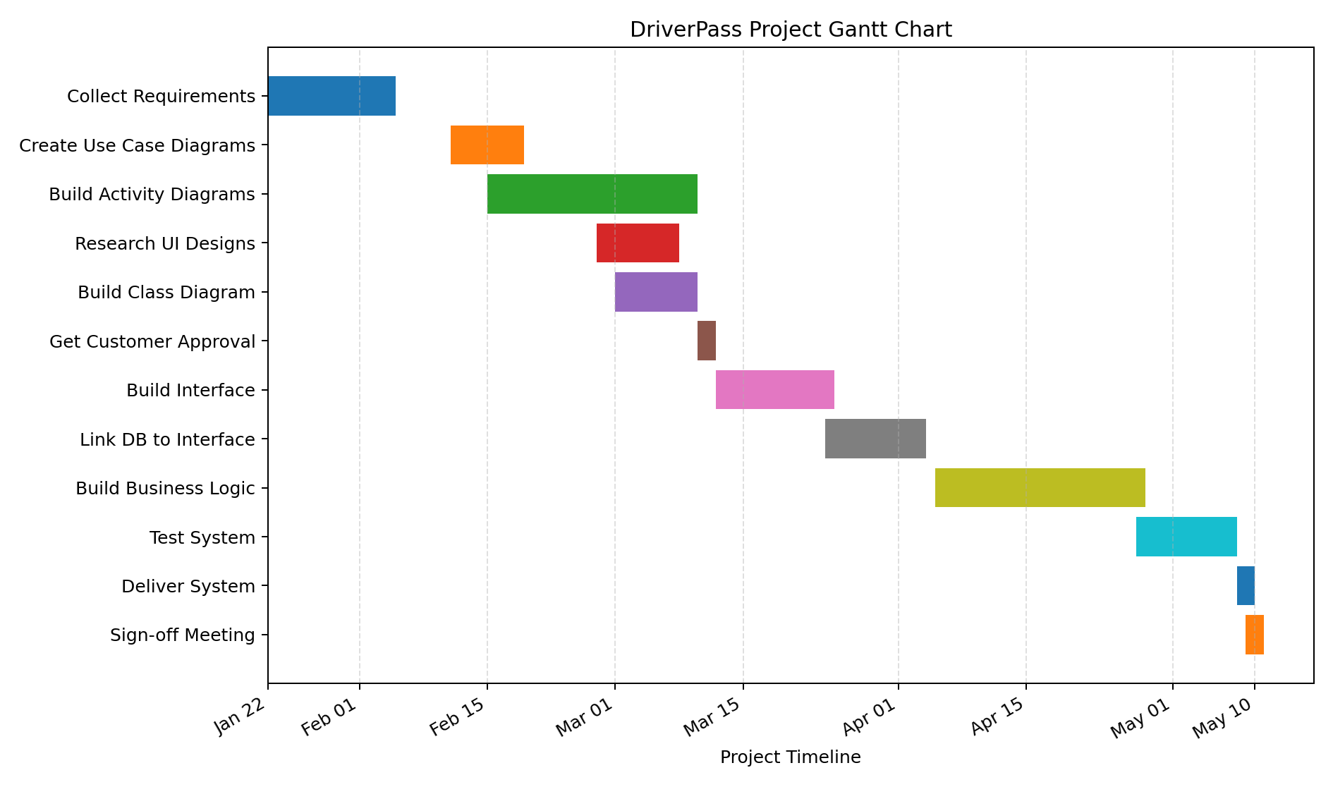
Figure 1. DriverPass Project Gantt Chart

